**EXAM FOLDER**

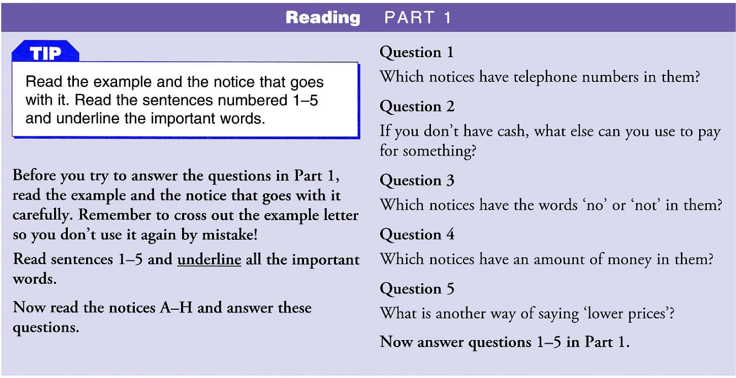

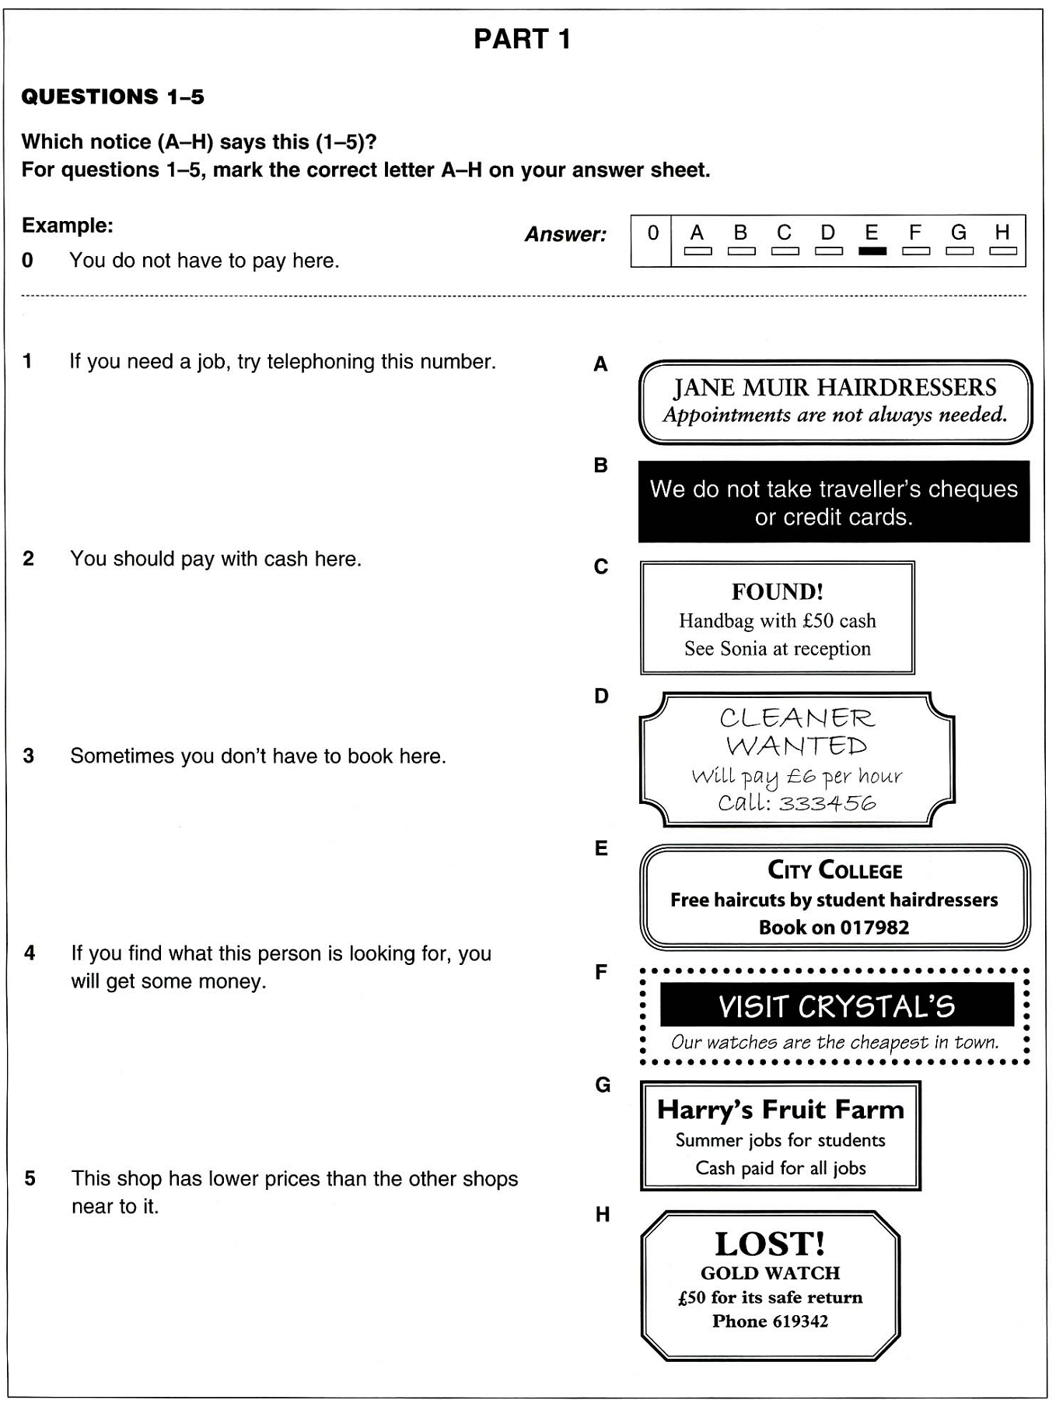

**ANSWER KEYS**

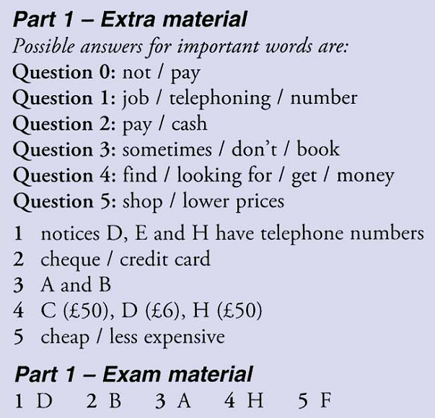

SOURCE:

*Key English Test Extra.* Cambridge University Press.